

MA478 – Generalized Linear Models
Homework Assignment #2 Requirements

Overview
In this homework assignment, you will explore, analyze, and model a data set containing approximately 8000 records representing a customer at an auto insurance company. Each record has two response variables. The first response variable, TARGET_FLAG, is a 1 or a 0. A “1” means that the person was in a car crash. A zero means that the person was not in a car crash. The second response variable is TARGET_AMT. This value is zero if the person didn’t crash their car. But if they did crash their car, this number will be a value greater than zero.

Your objective is to build binomial response (logistic regression) and multiple linear regression models on the training data to predict the probability that a person will crash their car and the amount of money it will cost if the person does crash their car. You can only use the variables given to you (or variables that you derive from the variables provided). Below is a short description of the variables of interest in the data set:

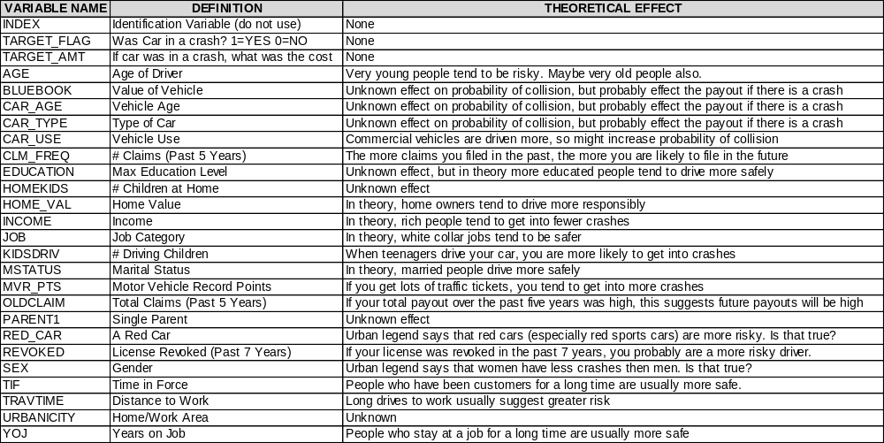

Deliverables:
- A professionally written report submitted in class on Lesson 12. Your write-up should have four sections. Each one is described below. You may assume you are addressing me as an applied statistics and data science savvy Army officer, so please do not need to shy away from technical details.

- Assigned predictions (probabilities, classifications, and cost) for the evaluation data set in an Appendix. Use a 0.5 threshold for your probability-classification cutoff.

- Include your R statistical programming code in an Appendix (after the predictions).

Write Up:

- DATA EXPLORATION (25 Points)

Provide a short introduction with a clearly stated research question(s) for the assignment. Describe the size and the variables in the insurance training data set. Consider that too much detail will cause a manager to lose interest while too little detail will make the manager consider that you aren’t doing your job. Some suggestions are given below. Please do NOT treat this as a check list of things to do to complete the assignment. You should have your own thoughts on what to tell the boss. These are just ideas.
  - Mean / Standard Deviation / Median / Other Summary Statistics
  - Bar Chart or Box Plot of the Data / Other Data Visualizations
  - Is the data correlated to the target variable (or to other variables?)
  - Are any of the variables missing and need to be imputed “fixed”?

- DATA PREPARATION (25 Points)

Describe how you have transformed the data by changing the original variables or creating new variables. If you did transform the data or create new variables, discuss why you did this. Here are some possible transformations.
  - Fix missing values (maybe with a Mean or Median value or other imputation techniques)
  - Create flags to suggest if a variable was missing
  - Transform data by putting it into buckets
  - Mathematical transforms such as log or square root (or use Box-Cox)
  - Combine variables (such as ratios or adding or multiplying) to create new variables

- BUILD MODELS (25 Points)

Using the training data set, build at least three different binary logistic regression models and at least two different multiple linear regression models, using different variables (or the same variables with different transformations). You may select the variables manually, use an approach such as Forward or Stepwise, or use a combination of techniques. Describe the techniques you used. If you manually selected a variable for inclusion into the model or exclusion into the model, indicate why this was done. Also, be sure to thoroughly discuss the regression model outputs and the coefficient estimates, do they make sense? For example, if a person has a lot of traffic tickets, you would reasonably expect that person to have more car crashes. If the coefficient is negative (suggesting that the person is a safer driver), then that needs to be discussed. Are you keeping the model even though it is counter intuitive? Why? The boss needs to know.

- SELECT MODELS (25 Points)

Decide on the model performance criteria you are using for selecting the best binary logistic regression model and the best multiple linear regression model. Will you select models with slightly worse performance if it makes more sense or is more parsimonious? Discuss why you selected your models and provide statistical inferences for each. Provide a comparison table of the performance metrics for all the models. For the binary logistic regression model, will you use a performance metric such as log likelihood, AIC, ROC curve, etc.? Using the training data set, determine performance of the binary logistic regression models based on (a) accuracy, (b) classification error rate, (c) precision, (d) sensitivity, (e) specificity, (f) F1 score, (g) AUC, and (h) confusion matrix. For the multiple linear regression model, will you use a metric such as Adjusted R², RMSE, etc.? Using the training data set, determine performance of the multiple linear regression models based on (a) mean squared error, (b) R², (c) F-statistic, and (d) residual plots. Be sure to discuss multi-collinearity issues (if any) and discuss other relevant regression model output. Make predictions using the evaluation data set.

